

De La Salle University

College of Computer Studies

Software Technology Department

**GIOVANA**

UI Mock-Ups

|  |  |
| --- | --- |
| **Team Name** | Giovana |
| **Section** | S11 |
| **Team Members** | Arevalo, Mark Anthony A.  Asaba, Hiroki M.  Chuasang, Carvin  Co, Nikki R.  Corpuz, Paulo Neil E.  Gaw, Walchester S.  Lim, Patricia M.  Matias, Glenn M.  Santos, Kit D.  Shen, Andric Michael L. |
| **Date Submitted** |  |

1. Log-In Page

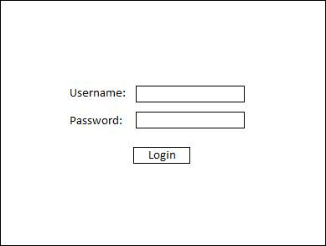

1. Adding Transaction

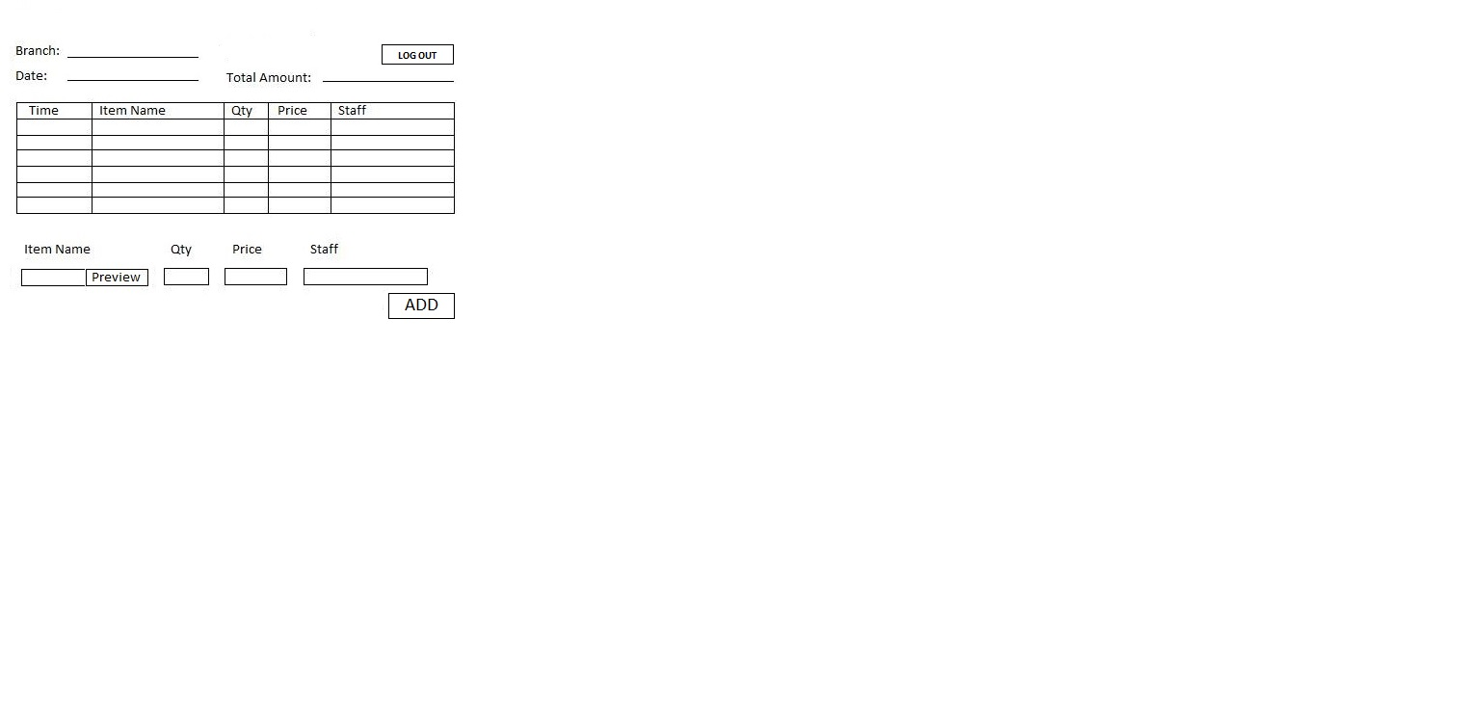

1. Client Home Page

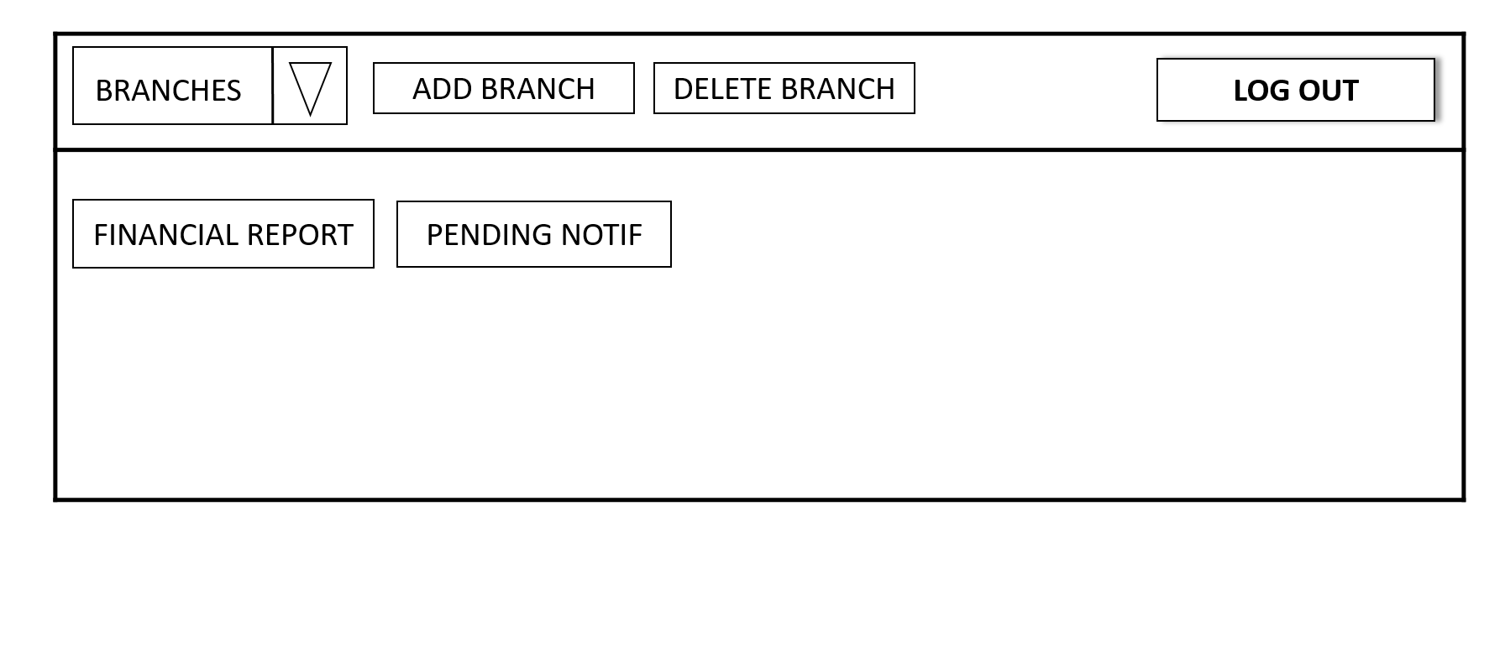

1. Add Account

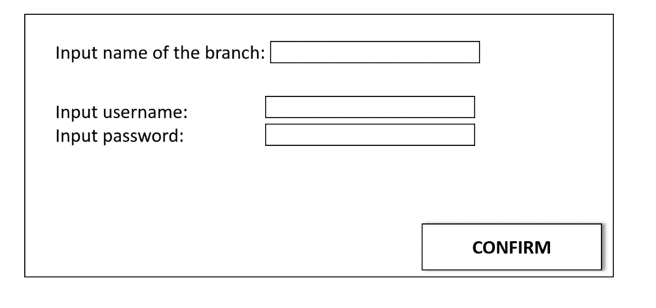

1. Client Daily Report

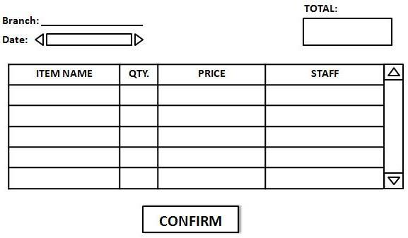

1. Client Branch Report

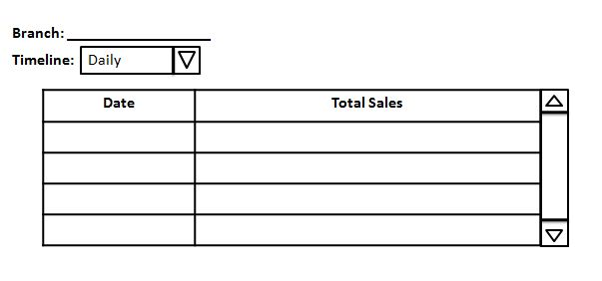

1. Financial Report

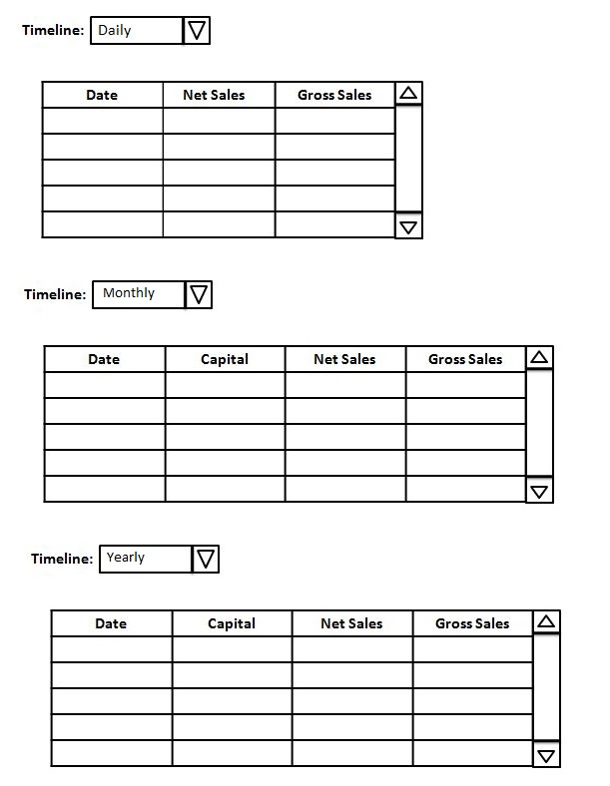

1. Inventory Page

